Verifying Newton's Second Law
The objective of this lab is to verify the two statements of Newton's second law, which
state that the acceleration is directly proportional to net force, and the acceleration is
inversely proportional to the mass.

Part 1 Verify: For an object of given mass M, the acceleration of the object is proportional to the net force exerted on the Object:

- Constant: Mass of the object
- Variables: Net Force applied on the object F, and acceleration of the object a.

- Lab Materials used:_____________________________________

Procedure:

Data:
- Constants
The Mass of the Object: M in kg
The distance traveled by the Object: x in meters

- Variables:

 | Net Force (N) | Acceleration(m/s/s) | Time(s)

- Plot the graph of F vs. a on the graph paper attached

Part 2 Verify: For a given net force applied on an object, the acceleration of the object is inversely proportional to the mass of the object: a ∝ 1/M

- Constant: Net force applied on object
- Variables: Mass of the object M, and acceleration of the object a.

- Lab Materials used:_____________________________________
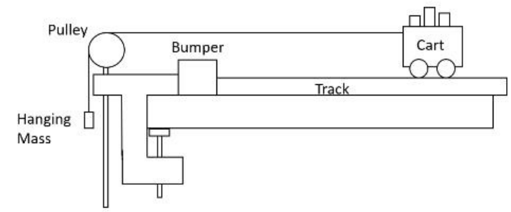
Procedure:

Data:
- Constants
The Net force applied on the object: F in Newtons
The distance traveled by the Object: x in meters

- Variables:

1/M | Mass (kg) | Acceleration(m/s/s) | Time(s)

- Plot the graph of a vs. 1/M on the graph paper attached

